

Mini Project Report - 01

Master of Computer Application – Game Development
Semester – I

Sub: Front-End Frameworks and Technologies

Topic: BookBay – Bookstore
By
Name: Shaurya Venkta
Reg no.: 1340826015

Faculty Name: VEERA RAGHAV K

Faculty Signature: _______________

Department of Computer Application
Alliance University
Chandapura - Anekal Main Road, Anekal
Bengaluru - 562 106
October 2026

INDEX

FIG NO. | NAME | PG NO.
1 | INTRODUCTION | 3
2 | INPUT CODE | 4-15
3 | OUTPUT | 16-19
4 | CONCLUSION | 20

INTRODUCTION

BookBay is a simple and user-friendly online bookstore website developed for purchasing and exploring books online. The website is created according to the assigned Bookstore theme for Shaurya Venkta.
The main purpose of BookBay is to provide users with an easy way to browse different books and view important details such as the book title, author, genre, price, and cover image. The website includes books from categories such as Fiction, Fantasy, Science, Self-help, Wellness, Art, and Classics.
Users can search for a particular book by entering its title or author name. They can also filter the displayed books according to their genre. Each book has an option to add it to the shopping cart. The cart displays the selected books, the number of books added, and the total amount in Indian rupees.
The website is developed using HTML, CSS, and JavaScript. HTML is used to create the structure of the website, CSS is used for styling and responsive layout, and JavaScript is used to implement search, genre filtering, book selection, and cart functionality. Book cover images are loaded automatically using the Open Library Covers service.
The website has a simple, clean, and responsive design so that it can be viewed comfortably on desktops, tablets, and mobile devices. BookBay demonstrates the basic features of an e-commerce website in a clear and easy-to-use manner.
.

INPUT CODE

File Name:- BookStore.htm

<!DOCTYPE html>
<html lang=”en”>
<head>
<meta charset=”UTF-8”>
<meta name=”viewport” content=”width=device-width, initial-scale=1.0”>
<title>BookBay Bookstore</title>
<link rel=”stylesheet” href=”BookStore.css”>
</head>
<body>
<header>
<div class=”header-content”>
<a class=”logo” href=”#”>Book<span>Bay</span></a>
<nav>
<a href=”#home”>Home</a>
<a href=”#books”>Books</a>
<a href=”#about”>About</a>
</nav>
<button id=”cartButton”>Cart (<span id=”cartCount”>0</span>)</button>
</div>
</header>

<main>
<section class=”welcome” id=”home”>
<h1>Welcome to BookBay</h1>
<p>Find interesting books for your reading list.</p>
<a href=”#books”>View Books</a>
</section>

<section class=”books-section” id=”books”>
<div class=”section-title”>
<h2>Our Books</h2>
<input id=”search” type=”search” placeholder=”Search books”>
</div>
<div id=”filters” class=”filters”></div>
<div id=”bookList” class=”book-list”></div>
<p id=”noBooks” hidden>No books found.</p>
</section>

<section class=”about” id=”about”>
<h2>About BookBay</h2>
<p>BookBay is a small online bookstore made for book lovers.</p>
</section>
</main>

<div id=”cart” class=”cart”>
<button id=”closeCart” class=”close”>X</button>
<h2>Your Cart</h2>
<div id=”cartItems”></div>
<p>Total: Rs. <span id=”total”>0.00</span></p>
</div>
<div id=”shade” class=”shade” hidden></div>

<script src=”BookStore.js”></script>
</body>
</html>

File Name:-BookStore.css

* {
box-sizing: border-box;
}

body {
margin: 0;
color: #333;
background: #f5f3ef;
font-family: Arial, sans-serif;
}

header {
background: white;
border-bottom: 1px solid #ddd;
}

.header-content {
width: 90%;
max-width: 1050px;
min-height: 65px;
margin: auto;
display: flex;
align-items: center;
justify-content: space-between;
}

.logo {
color: #333;
font-size: 23px;
font-weight: bold;
text-decoration: none;
}

.logo span {
color: #607d6d;
}

nav a {
margin: 0 8px;
color: #555;
font-size: 14px;
text-decoration: none;
}

button,
.welcome a {
border: 0;
border-radius: 3px;
color: white;
background: #607d6d;
padding: 9px 13px;
cursor: pointer;
}

.welcome {
padding: 70px 5%;
background: #e5ece7;
text-align: center;
}

h1,
h2 {
font-family: Georgia, serif;
font-weight: normal;
}

h1 {
margin: 0 0 12px;
color: #304238;
font-size: 45px;
}

.welcome p {
margin-bottom: 25px;
color: #666;
}

.welcome a {
display: inline-block;
text-decoration: none;
}

.books-section,
.about {
width: 90%;
max-width: 1050px;
margin: auto;
padding: 45px 0;
}

.section-title {
display: flex;
align-items: center;
justify-content: space-between;
}

h2 {
color: #304238;
font-size: 30px;
}

#search {
width: 230px;
padding: 10px;
border: 1px solid #ccc;
border-radius: 3px;
}

.filters {
margin: 5px 0 25px;
}

.filters button {
margin: 3px;
color: #52685a;
background: white;
border: 1px solid #b9c8bd;
}

.filters .selected,
.filters button:hover {
color: white;
background: #607d6d;
}

.book-list {
display: grid;
grid-template-columns: repeat(4, 1fr);
gap: 18px;
}

.book {
background: white;
border: 1px solid #ddd;
}

.book img {
width: 100%;
height: 210px;
display: block;
object-fit: cover;
background: #75877b;
}

.book-info {
padding: 12px;
}

.book h3 {
margin: 0 0 7px;
font-family: Georgia, serif;
font-size: 17px;
font-weight: normal;
}

.book p {
margin: 6px 0;
color: #666;
font-size: 12px;
}

.book .genre {
color: #52685a;
}

.book .price {
color: #333;
font-size: 14px;
font-weight: bold;
}

.book .add {
width: 100%;
margin-top: 10px;
color: #607d6d;
background: white;
border: 1px solid #607d6d;
}

.book .add:hover {
color: white;
background: #607d6d;
}

.about {
max-width: none;
padding: 35px 5%;
background: #e5ece7;
text-align: center;
}

.about p {
color: #666;
}

.cart {
position: fixed;
top: 0;
right: -360px;
z-index: 3;
width: 340px;
height: 100%;
padding: 25px;
background: white;
border-left: 1px solid #ddd;
transition: right .2s;
}

.cart.open {
right: 0;
}

.close {
float: right;
padding: 5px 8px;
}

.cart-item {
padding: 12px 0;
border-bottom: 1px solid #eee;
}

.shade {
position: fixed;
inset: 0;
z-index: 2;
background: rgba(0, 0, 0, .3);
}

@media (max-width: 750px) {
.book-list {
grid-template-columns: repeat(2, 1fr);
}
}

@media (max-width: 500px) {
nav {
display: none;
}

.section-title {
display: block;
}

#search {
width: 100%;
}

.book-list {
grid-template-columns: 1fr 1fr;
gap: 10px;
}

.book img {
height: 170px;
}
}

File Name:-BookStore.js

const books = [
["The Midnight Library", "Matt Haig", "Fiction", 999, "9780525559474"],
["Atomic Habits", "James Clear", "Self-help", 1549, "9780735211292"],
["The House in the Cerulean Sea", "TJ Klune", "Fantasy", 1299, "9781250217288"],
["Tomorrow, and Tomorrow", "Gabrielle Zevin", "Fiction", 1399, "9780593321201"],
["A Brief History of Time", "Stephen Hawking", "Science", 1699, "9780553380163"],
["Ikigai", "Héctor García", "Wellness", 999, "9780143130727"],
["The Creative Act", "Rick Rubin", "Art", 1799, "9780593652886"],
["The Alchemist", "Paulo Coelho", "Classics", 899, "9780062315007"]
];

let selectedGenre = "All";
let cart = [];

function showFilters() {
const genres = ["All"];
books.forEach(function (book) {
if (!genres.includes(book[2])) genres.push(book[2]);
});

document.getElementById("filters").innerHTML = genres.map(function (genre) {
return `<button class="${genre === selectedGenre ? "selected" : ""}"
data-genre="${genre}">${genre}</button>`;
}).join("");
}

function showBooks() {
const search = document.getElementById("search").value.toLowerCase();
const list = books.filter(function (book) {
const hasGenre = selectedGenre === "All" || book[2] === selectedGenre;
const hasSearch = (book[0] + book[1]).toLowerCase().includes(search);
return hasGenre && hasSearch;
});

document.getElementById("bookList").innerHTML = list.map(function (book, index) {
return `<div class="book">
<img src="https://covers.openlibrary.org/b/isbn/${book[4]}-M.jpg"
alt="${book[0]} cover">
<div class="book-info">
<h3>${book[0]}</h3>
<p>Author: ${book[1]}</p>
<p class="genre">Genre: ${book[2]}</p>
<p class="price">Rs. ${book[3].toLocaleString("en-IN")}</p>
<button class="add" data-index="${books.indexOf(book)}">Add to cart</button>
</div>
</div>`;
}).join("");

document.getElementById("noBooks").hidden = list.length > 0;
}

function showCart() {
let total = 0;
document.getElementById("cartItems").innerHTML = cart.map(function (item) {
total += item[3];
return `<div class="cart-item">${item[0]} - Rs. ${item[3].toLocaleString("en-IN")}</div>`;
}).join("");
document.getElementById("cartCount").textContent = cart.length;
document.getElementById("total").textContent = total.toLocaleString("en-IN");
}

document.getElementById("filters").addEventListener("click", function (event) {
if (event.target.dataset.genre) {
selectedGenre = event.target.dataset.genre;
showFilters();
showBooks();
}
});

document.getElementById("bookList").addEventListener("click", function (event) {
if (event.target.dataset.index) {
cart.push(books[event.target.dataset.index]);
showCart();
alert("Book added to cart");
}
});

document.getElementById("search").addEventListener("input", showBooks);

document.getElementById("cartButton").addEventListener("click", function () {
document.getElementById("cart").classList.add("open");
document.getElementById("shade").hidden = false;
});

function closeCart() {
document.getElementById("cart").classList.remove("open");
document.getElementById("shade").hidden = true;
}

document.getElementById("closeCart").addEventListener("click", closeCart);
document.getElementById("shade").addEventListener("click", closeCart);

showFilters();
showBooks();
showCart();

OUTPUT

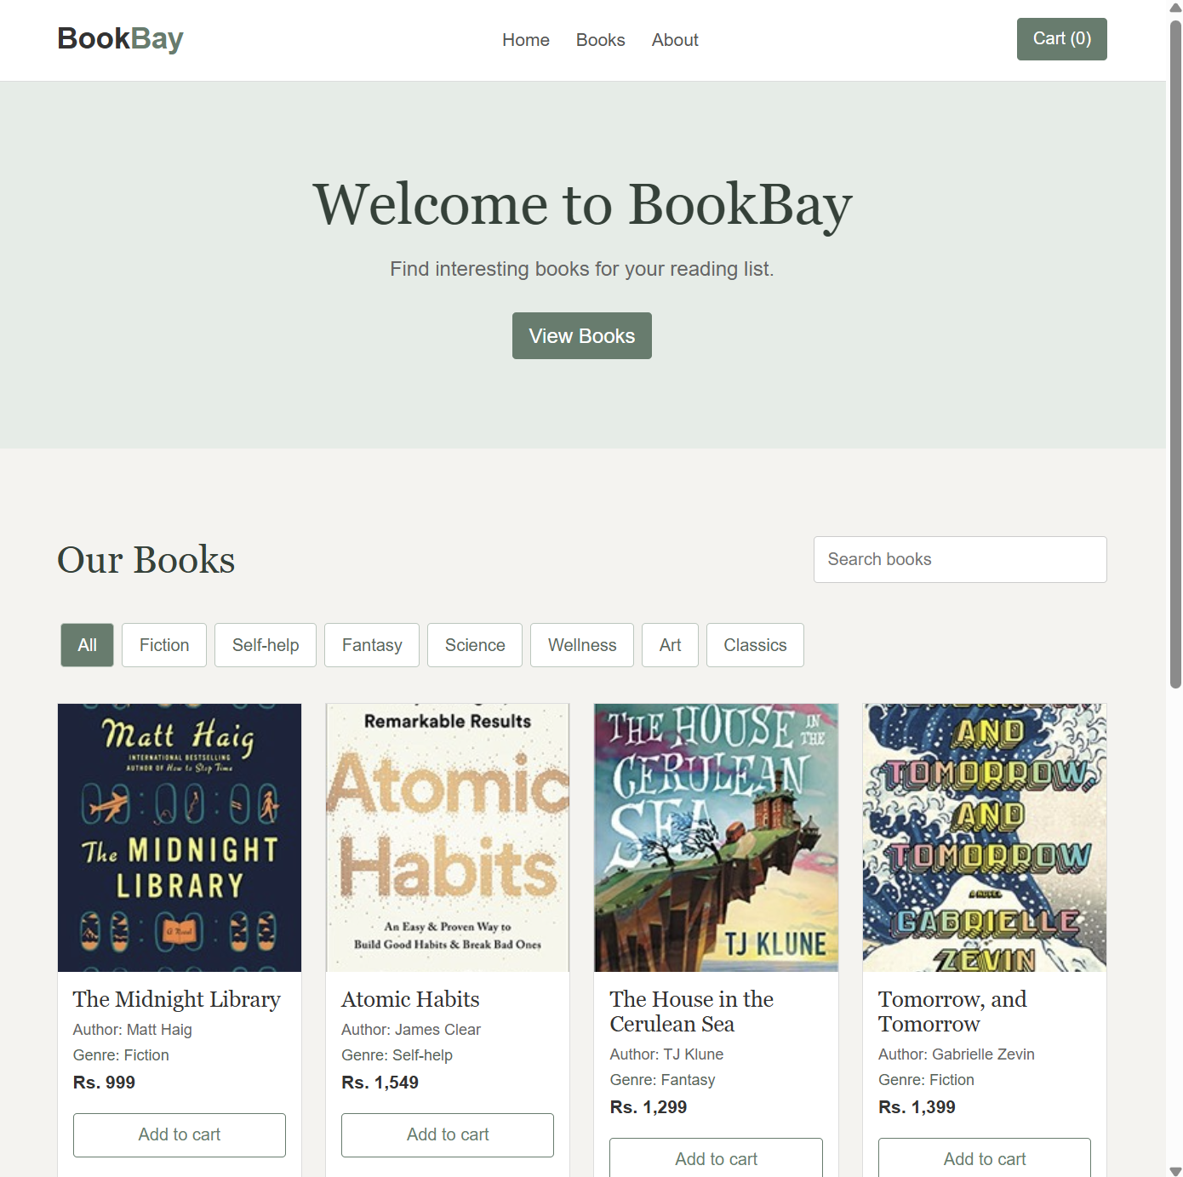

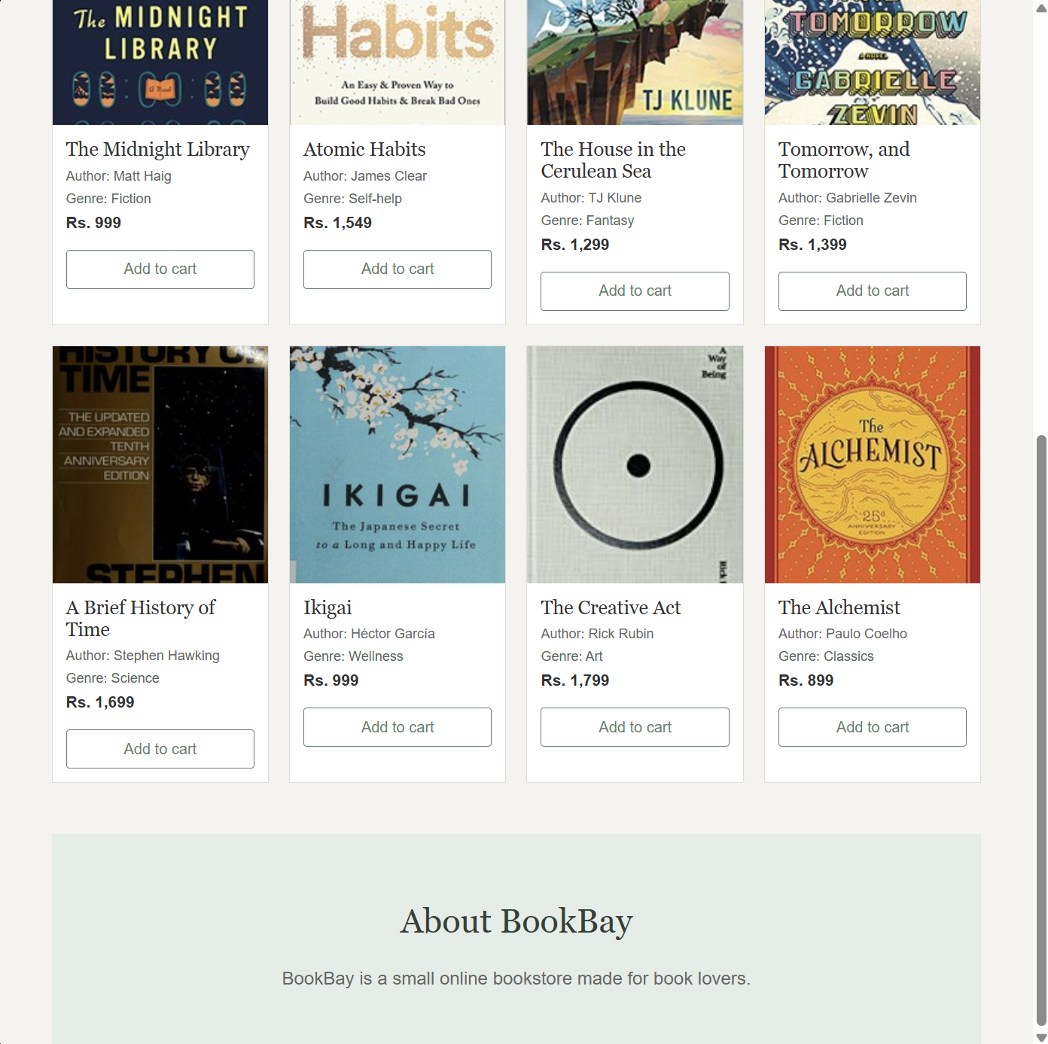

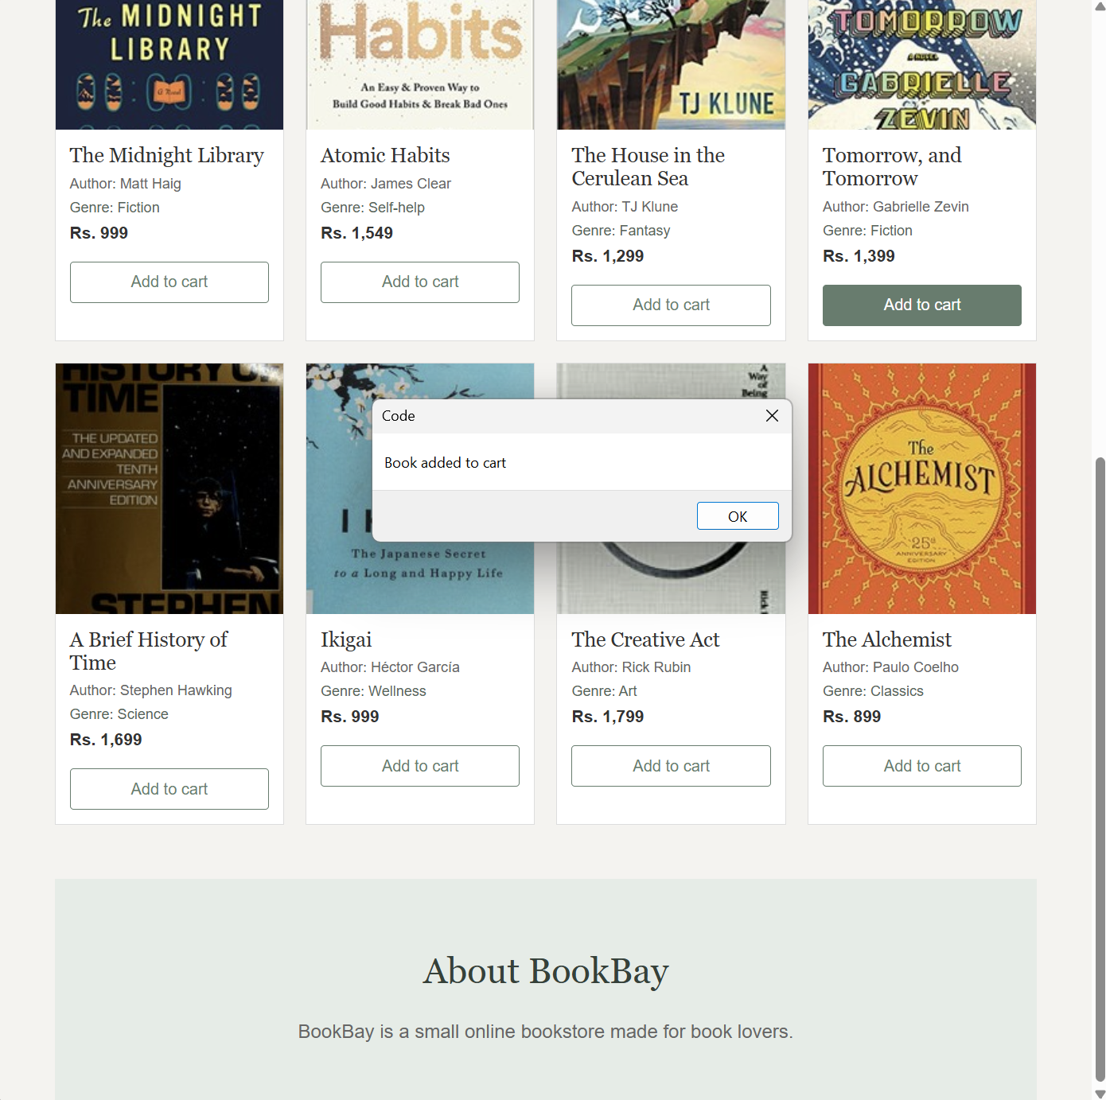

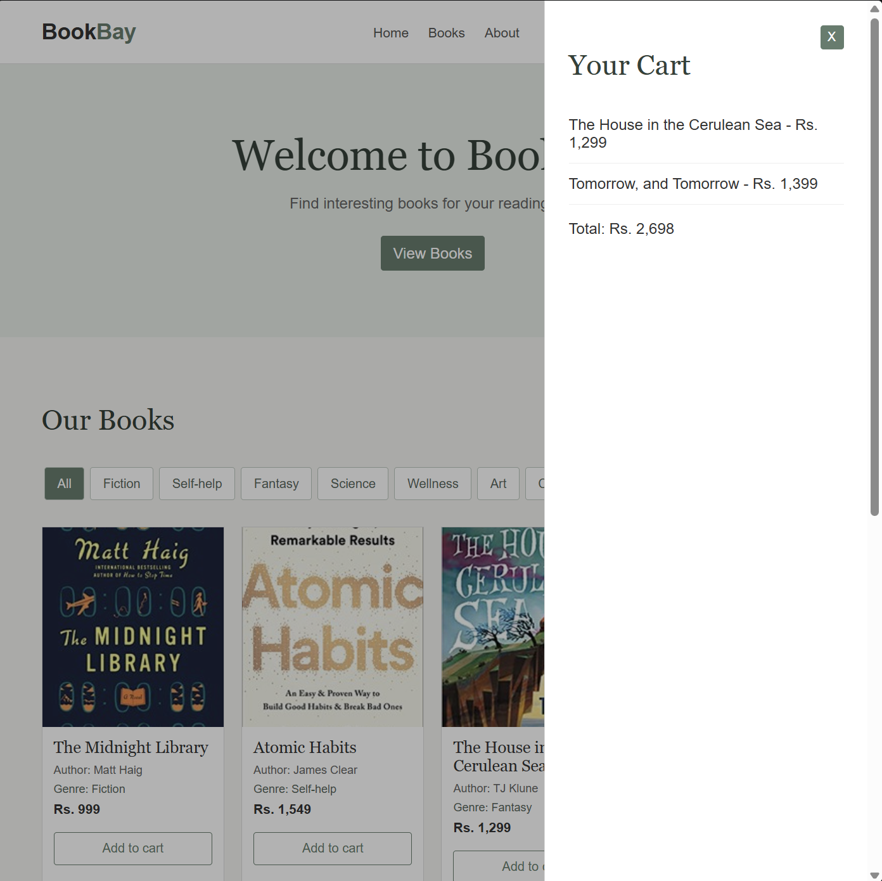

CONCLUSION

The BookBay website successfully demonstrates the basic features of an online bookstore. It allows users to view books along with their titles, authors, genres, cover images, and prices in Indian rupees. The search and genre filter features make it easier for users to find suitable books.
The shopping cart allows users to add selected books and view the total cost of their order. The website was developed using HTML, CSS, and JavaScript, which helped in creating the structure, design, and interactive features.
The simple and responsive design makes BookBay easy to use on different screen sizes. Overall, this project helped in understanding important web development concepts such as webpage structure, styling, JavaScript events, arrays, DOM manipulation, filtering, and basic e-commerce functionality.

